**Formative Assignment 1**

|  |  |
| --- | --- |
| Module Name | Application Implementation (Agile Project Management) |
| Course Name | Bachelor of Technology in Software Engineering |
| Assignment Title | Project Management Plan for implementing the community portal |

|  |  |
| --- | --- |
| Learner Name | Francis Roel L. Abarca – bdse-0922-113 |

|  |
| --- |
| Learner declaration |
| I certify that the work submitted for this assignment is my own and research sources are fully acknowledged.  Student signature: Date: 7/18/2023 |

## Purpose of this assignment

To demonstrate your capabilities in the following areas:

* Preparing Requirement Specifications
* Developing Project Plan

## Submission Format

The submission is in the form of an individual written report with examples and illustrations. This should be written in a concise, formal academic style using single spacing and font size 12.You are required to make use of headings, paragraphs, and subsections as appropriate, and all work must be supported with research and referenced using the Harvard referencing system. Please also provide a bibliography using the Harvard referencing system.

## Submission file

Submission File Name format: Cohort Code _Full Name_Assignment Number

E.g.: AIM-1222A_AliceTan_A1.docx

## Scenario

## You have been approached by ‘ABC Jobs Pte Ltd’ as a website developer to develop a community portal for Software Developers. For this module the scope is to Design, Develop, Implement & Document the data-driven website using the framework Spring boot and react.

The Scope of the Project is to design a Community Portal Similar to Linkedin.com. Users will be able to register in the portal using the Registration Page. Users of the portal can search for other users using various parameters such as First Name, Last Name, Company Name, City & Country. Users will be able to view the Public Profile of users after searching them. The portal allow users to login, request for forgotten password and Update their profile information.

The overview of the project is as below

There are 2 types of users in this Community portal. They are

1. Software Programmer
2. Administrator

## Software Programmer should be able to perform following functions in the portal

## 1. Allow the programmers to register in the portal, show a thank you page & send a registration confirmation email.

## 2. Search & Find Other Programmers after login and view their profile.

## 3. Provide Login Page

## 4. Provide password retrieval functionality.

## 5. Update their Profile after logging in.

## Following Functionality is part of Database Design & Will be enhanced as features as required in the Capstone Project, Depending on time availability.

## 6. Send Messages to Each Other on the Portal

## 7. Create Threads & Post Replies to a Thread

## 8. Post Job Opportunities in the Portal

## Administrator should be able to perform following functions in the portal

## 1. Administer user data.

## 2. Send bulk email inviting programmers to register on the community portal

## The portal consist of the following Key pages (For Reference)

## 1. Community Portal Home Page

## 2. Registration Page

## 3. Registration Confirmation Page

## 4. Update Profile Page

## 5. Search Users Page

## 6. List Search Results

## 7. Public Profile Page

## 8. Registration Confirmation Email

## 9. Login Page

## 10. Forget Password Page

## 11. Design the Forget Password Confirmation Page

## Following Functionality is part of Database Design & Will be enhanced as features as required in the Capstone Project, Depending on time availability.

## 

## 12. Send Messages

## 13. Read Messages

## 14. Post in Message Board

## 15. List Message Board

## 16. Read A Thread

## 17. Post Job Opportunities

## 18. List Job Opportunities & Responses

## You will be required to:

* Write a brief requirement specification for the Community Portal.
* Prepare the detailed project plan to implement the Community Portal

## Evidence to exhibit

* Requirements Specification
* Project Plan

Task Wise Solutions:

1. **Write a brief requirement specification for the Community Portal.**
   1. **Functional Requirements**

|  |  |  |  |
| --- | --- | --- | --- |
| **No** | **Requirements** | **Web Page / Process** | **Field Detail** |
| 1 | Register on the portal | Registration Page | First Name, Last name, Email address, Password, Company Name, City, Country |
| 2 | Receive a Confirmation Email | Registration Confirmation Page | Email Address |
| 3 | View a Thank You Page | Registration Confirmation Page | None |
| 4 | Search for other Software Engineers | Search Users Page | First Name, Last Name, Company Name, City, Country |
| 5 | View the Public Profile of other Software Engineers | Public Profile Page | First name, Last Name, Company Name, City, Country, Skills, Experience, Education |
| 6 | Log in to the portal | Login Page | Email address, password |
| 7 | Reset forgotten passwords | Forgot Password Page | Email Address |
| 8 | Update their profile information after logging in | Update Profile Page | First name, Last Name, Company Name, City, Country, Skills, Education |

* 1. **Non-Functional Requirements**

|  |  |  |
| --- | --- | --- |
| **No** | **Requirements** | **Purpose** |
| 1 | Accessibility | Ensure all users have equal access to the system. |
| 2 | Security | Protect user data from unauthorized access, disclosure, modification, or destruction. |
| 3 | Reliability | Ensure that users can access the system whenever they need to. |
| 4 | Navigation | Ensure that users can easily find the information and features they need. |
| 5 | Scalability | Ensure the system can handle an increasing number of users and transactions. |

* 1. **Technical Requirements**
     1. **Hardware (Minimum)**  
        CPU: Any x86 CPU with 2 cores  
        RAM: 4GB  
        Storage: 40GB SSD
     2. **Software (Minimum)**Operating System: Windows 10 or Linux  
        Database: MySQL 8.0  
        Web Server: Apache Tomcat 9  
        Java Version: Java 11.0.8
     3. **Database**A diagram of a flowchart

        Description automatically generated

1. **Project Plan**
   1. **Wireframe**
      1. **Landing Page** **A screenshot of a web page

         Description automatically generated**
      2. **Register Page  
         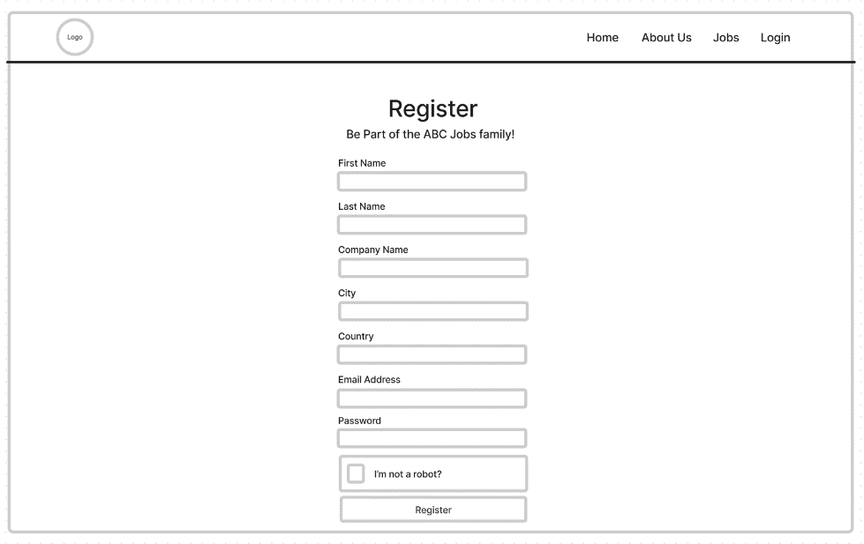**
      3. **Login Page** **A screenshot of a login screen

         Description automatically generated**
      4. **Forget Password Page** 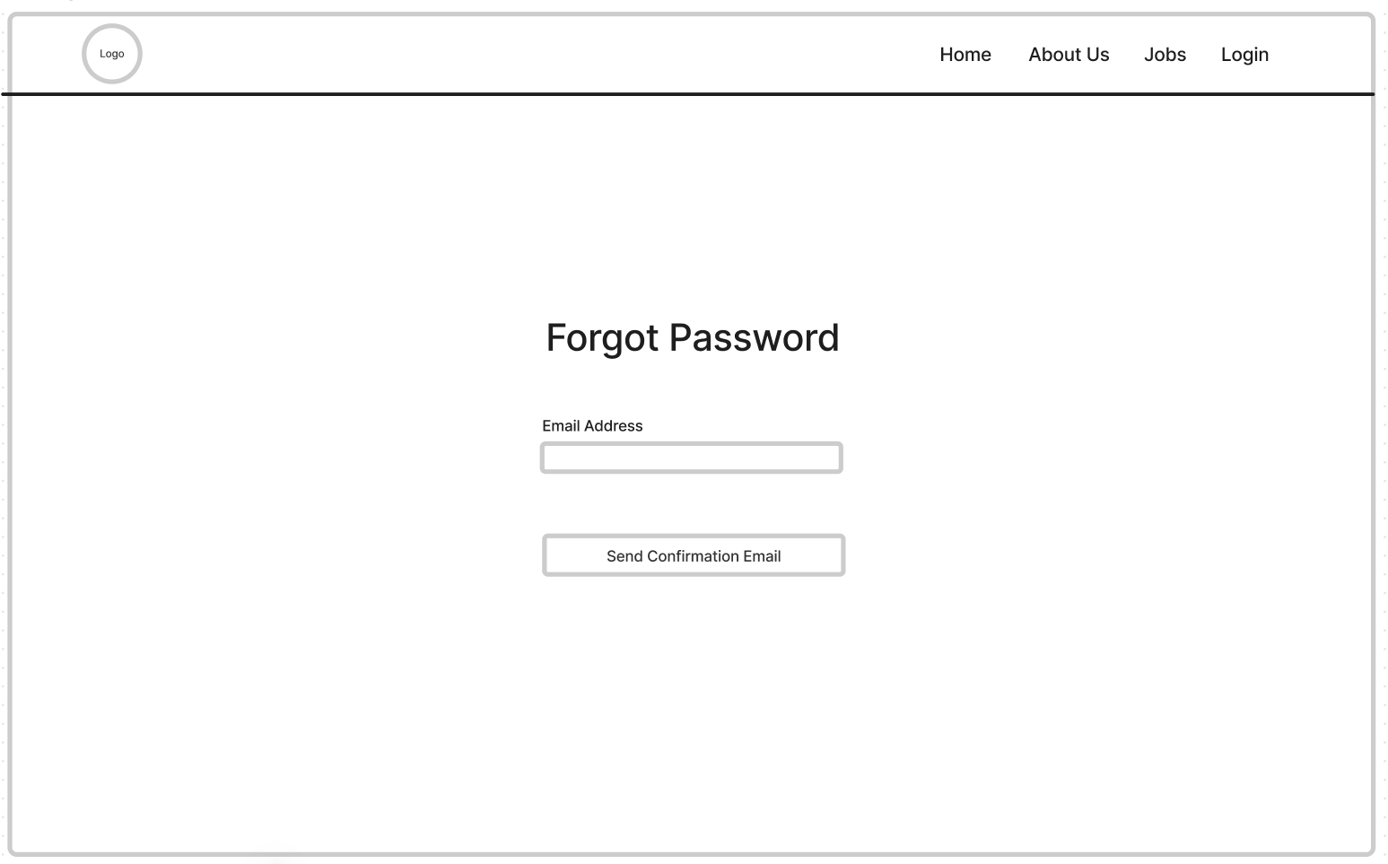
      5. **Reset Password Page** **A screenshot of a login screen

         Description automatically generated**
      6. **Confirm Email Page** **A screenshot of a computer

         Description automatically generated**
      7. **Registration Success Page** **A screenshot of a computer

         Description automatically generated**
      8. **Dashboard Page** 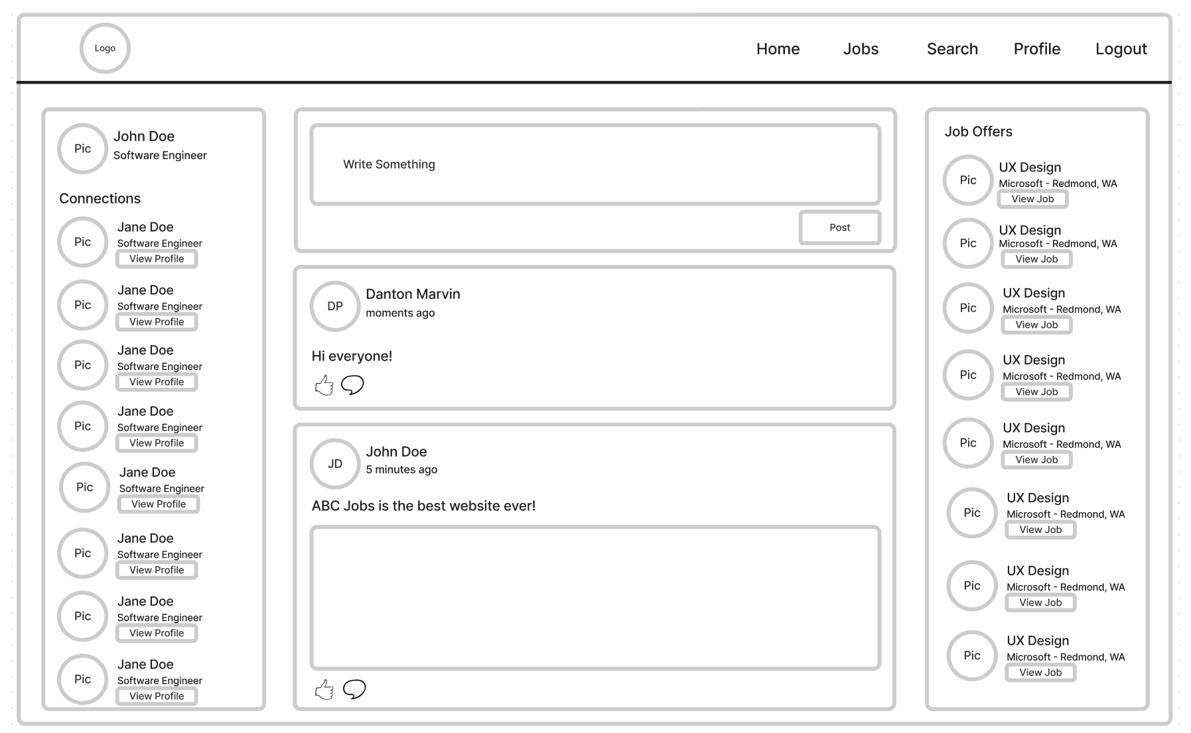
      9. **Search Page** 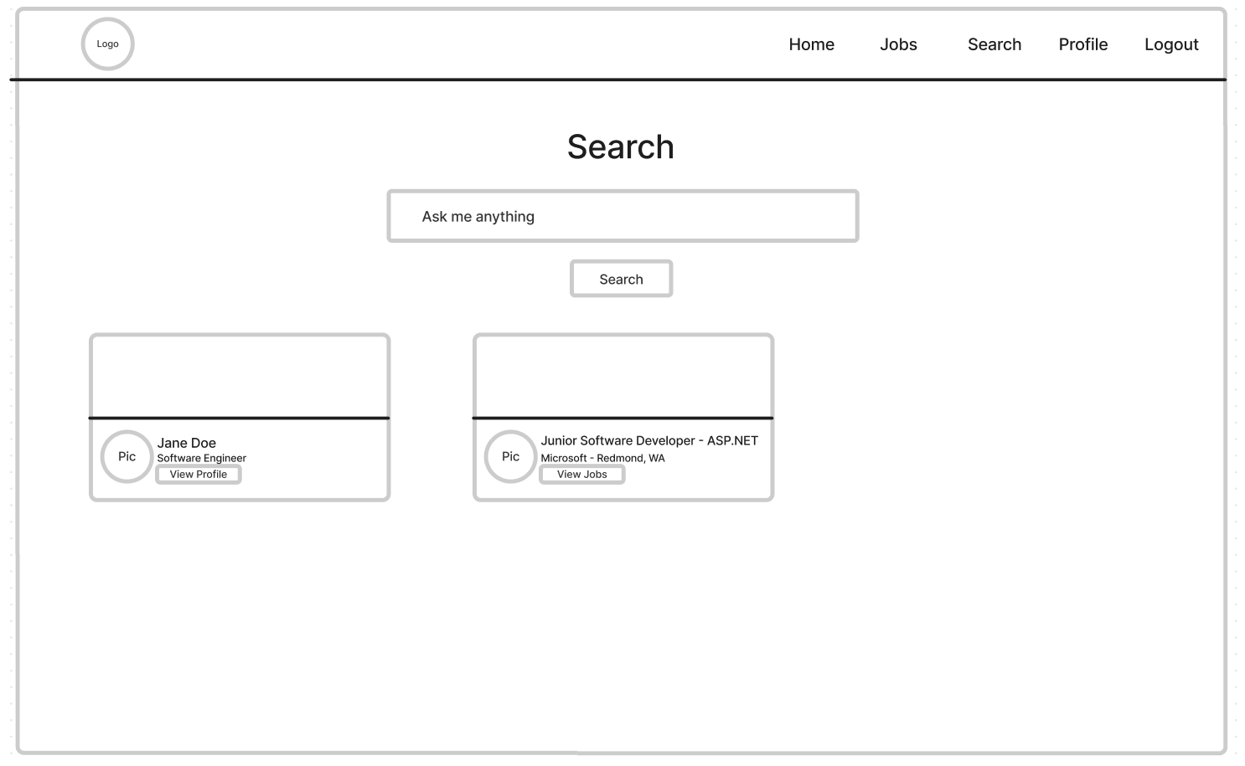
      10. **Profile Page** 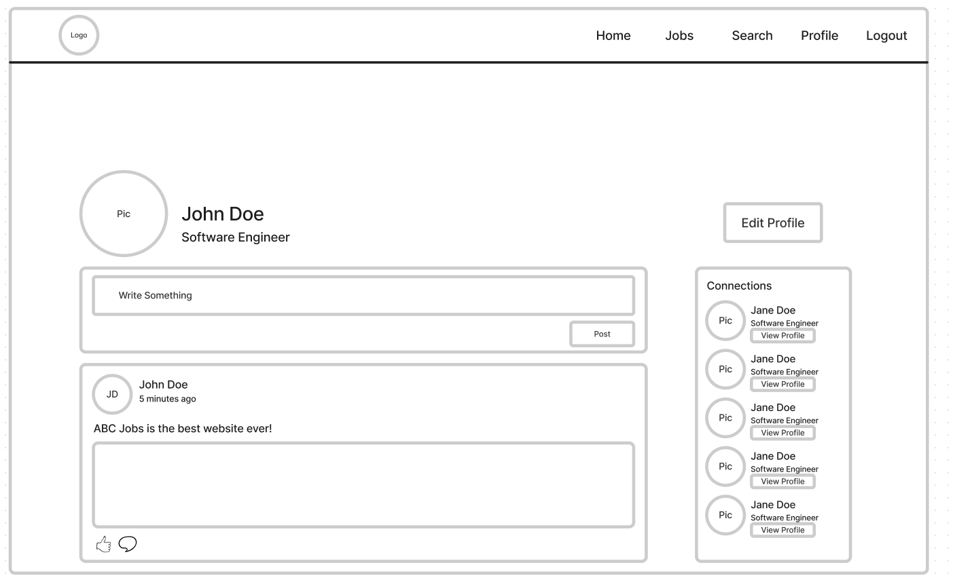
      11. **Edit Profile Page** **A screenshot of a computer

          Description automatically generated**
      12. **Admin Page** 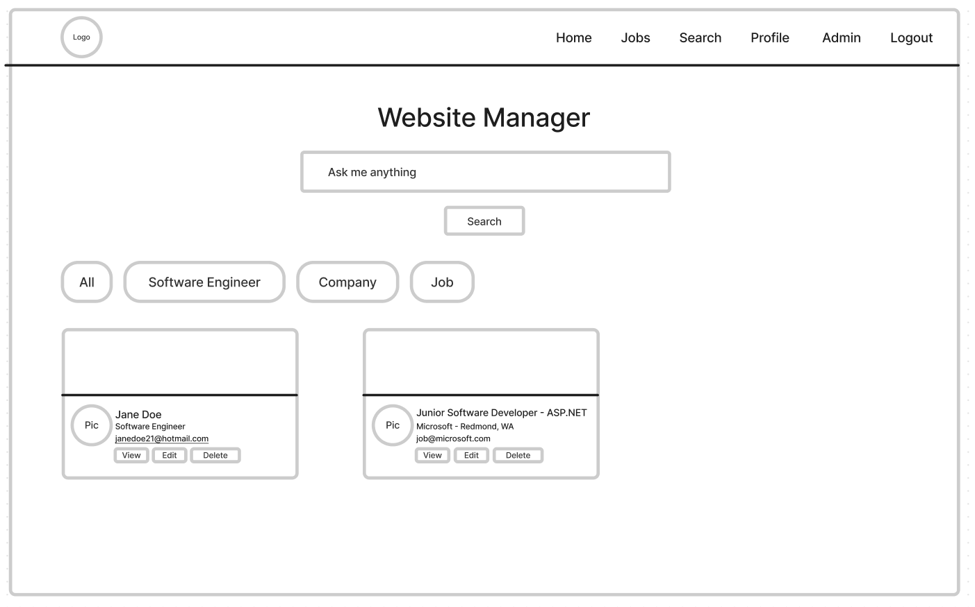
   2. **Storyboard**
      1. **Scenario Name: User Login**

|  |  |
| --- | --- |
| No | Ideas |
| 1 | Allan wants to log-on onto his newly created ABC Jobs account. He opens the ABC Jobs website then clicks on Login at the upper-right corner. Allan enters his email and password then clicks on Login. He will then be redirected immediately to his Dashboard page. |

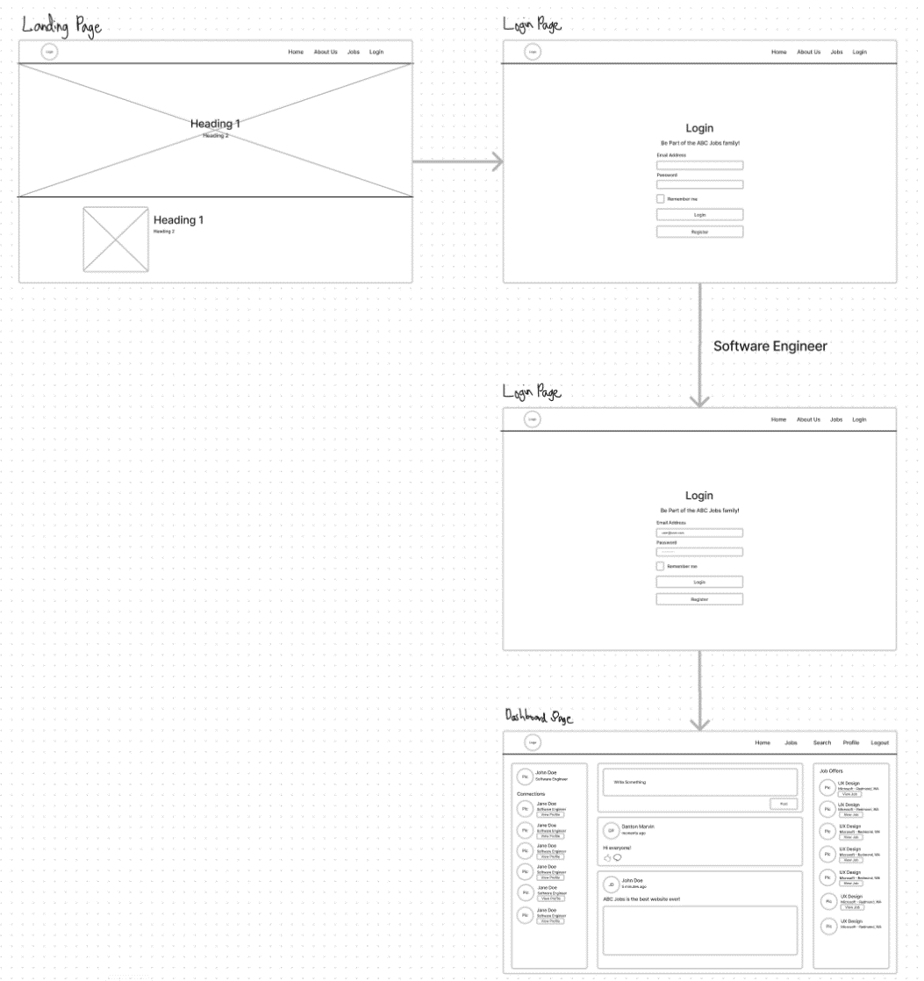

* 1. **Persona**
     1. A person with a beard and glasses smiling

        Description automatically generated**Software Engineer**

Name: John Doe

Age: 27

Occupation: Software Engineer

Background: John Doe has been a programmer for 14 years with experience spanning from Java to Swift. He has developed a lot of groundbreaking projects for both Microsoft, Apple and Google and a few startup companies from Silicon Valley. He aspires to apply for more jobs to build up his portfolio.

Goals:

﻿1. Expand John's programming skills by working on diverse projects across various platforms (such as Java, Swift, and other emerging technologies).

2. Continue building an impressive portfolio of groundbreaking projects to showcase his expertise in the field of software development.

3. Apply for more job opportunities that align with John's skills and experience, allowing him to further develop his career as a programmer while also contributing to innovative projects across various industries.

* + 1. A person with a beard

       Description automatically generated**Administrator**Name: Aldous Mark Bautista  
         
       Age: 37   
         
       Occupation: System Administrator  
         
       Background: Aldous is a world-renowned System Administrator responsible for maintaining multiple online services like Wix, Linode, Microsoft’s Azure and Amazon’s Web Services. He has an experience in System Administration and Software Engineering for over 20 years training at UC Berkley. He aspires to responsibly build, deploy, and manage ABC Jobs’s website for the foreseeable future.  
         
       Goals:  
       **﻿**1. Responsibly maintain and improve the performance of ABC Jobs' website by leveraging his extensive experience in System Administration and Software Engineering.

2. Ensure the reliability and security of the online services used for hosting, deploying, and managing the platform (such as Wix, Linode, Microsoft’s Azure, and Amazon’s Web Services).

3. Collaborate with the team to identify opportunities for innovation and growth to enhance the user experience on ABC Jobs' website and maintain its position as a leading online platform in the industry.

* 1. **Gantt Table** **A screenshot of a computer

     Description automatically generated**
  2. **Gantt Chart** 